**Fox Point Rental House**

**Newington, NH**

Newington NH/Fox Point. $2,400/mo. Beautiful 3 BR/1 BA. No Pets. Located in Town Park at Fox Point with scenic Great Bay views. Beach & dock access for dingy. Available on 12/1/18. References, credit check and criminal records check required.

E-mail Eleanor Boy if interested at eboy@townofnewingtonnh.com.

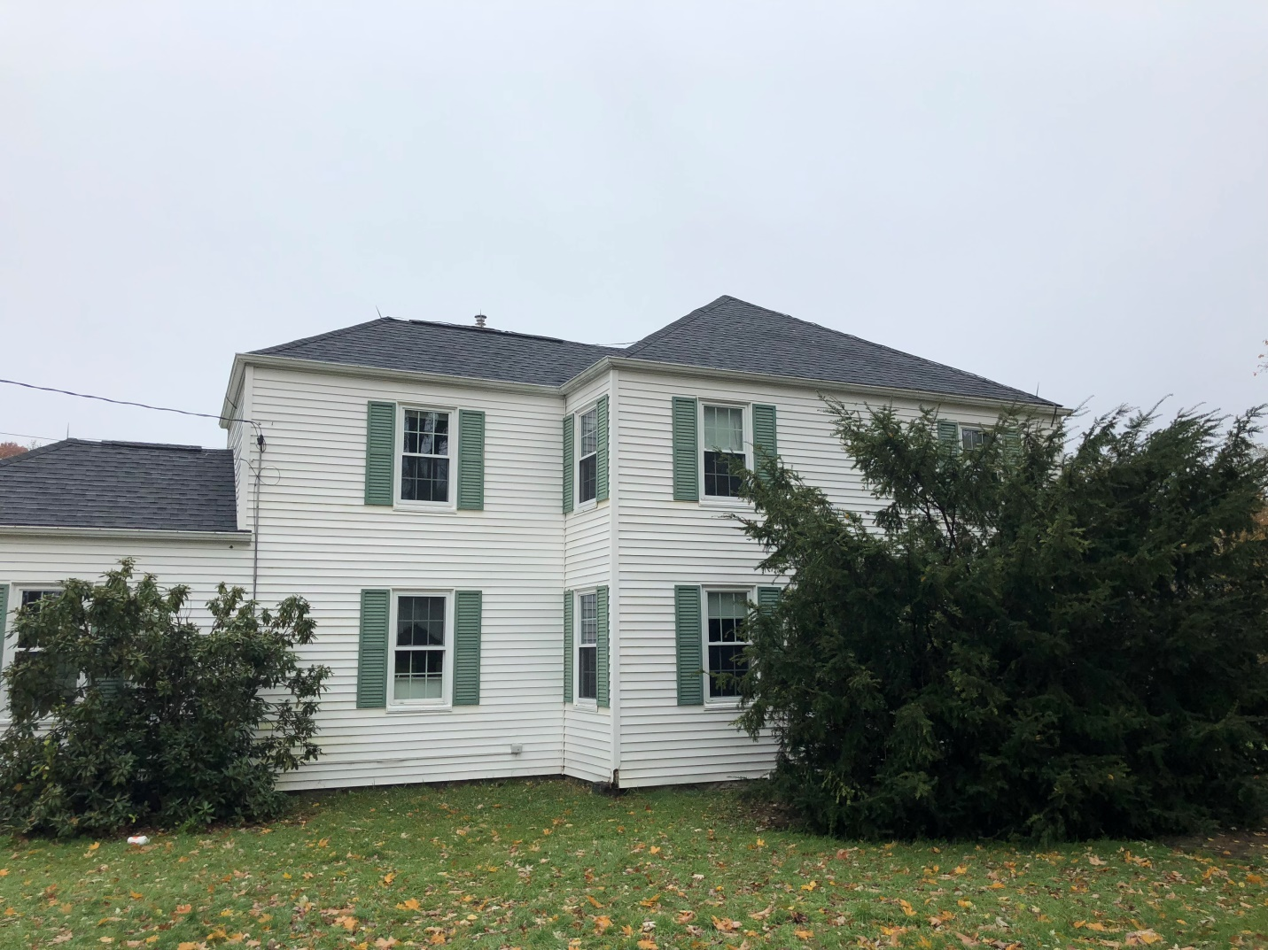

Fox Point Rental House.

Views of the Bay from Fox Point Rental House