Town of Newington
Conservation Commission
6:30 PM
at the
Newington Town Hall

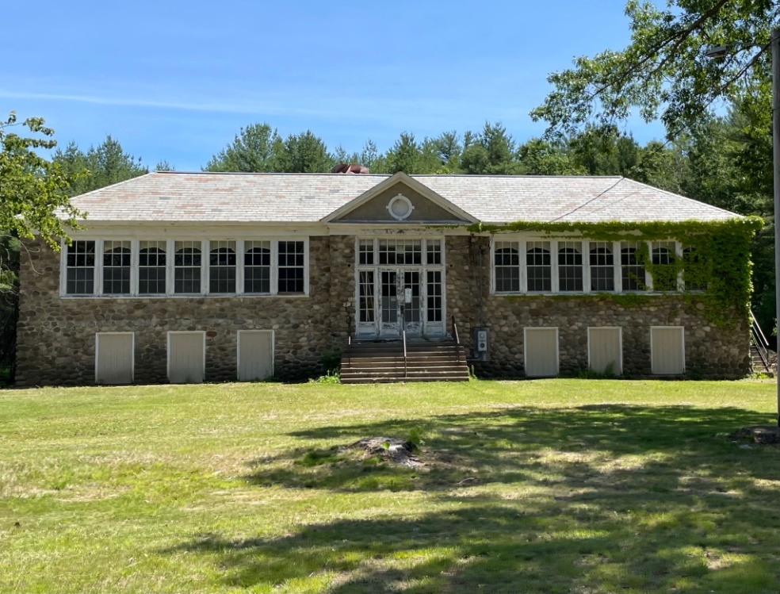

Thursday, August 10, 2023
205 Nimble Hill Road

A G E N D A

1) Discuss Fall 2023 projects / initiatives;

3) Review and approval of July 13, 2023 Minutes.

4) Other Business;

5) Adjournment.

